New Release

New Release

Seika Mini Plus –Portable note-taker

We are pleased to announce that we launched a new product- Seika Mini Plus!!
Mini Plus has special features such as Multi-language TTS speech, Web browser, email, document editing and Microsoft Word support, contacts, clock, calendar, calculator, cell phone and laptop connection through Bluetooth and USB type-C, etc., making your life more comfortable. We're very excited about its capabilities.
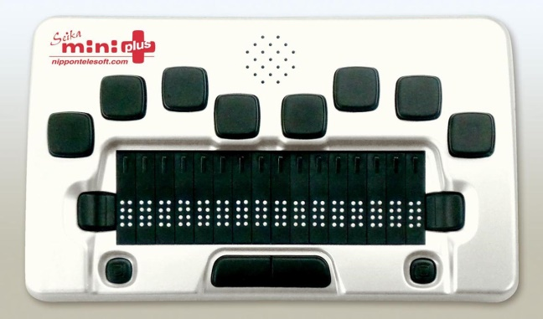
Specifications:
- 16 cells, 8-dots refreshable Braille display and corresponding routing keys
- 8-keys Braille keyboard and two space keys for input and function keys: pan left/right, two joysticks
- Supports 49 high voice quality TTS languages
- Standalone applications: Notepad, Reader, Web Browser, Email, Media Player, Contacts, Clock, Calendar, etc.
- Supports NVDA, JAWS, SuperNova, Window-Eyes, COBRA
- Build-in support: brl, brf, bes, txt, Microsoft docx, pdf files
- Braille display mode connecting with other PC/Mac/iPhone/iPad/android/tablet by using USB cable and Bluetooth
- 1.1 GHz CPU
- 1GB RAM, 8GB emmc storage
- WiFi 802.11 b/g/n and Bluetooth v.4.1 / BLE
- USB-A host ports and TF card
- USB-C port
- Internal stereo speaker(s) and microphone, 3.5 mm stereo headset jack
- Lithium rechargeable battery, USB Type-C charging
- Exceed 20 hours battery life
- Dimensions and Weight: 6.3 x 3.8 x 0.9 in, 0.7 lbs
- leather carrying case with a strap

